# Py City Schools Report

Jim Bentley, Data Scientist

## Executive Summary

This report provides an analysis of school performance within the Py district for the year.

Data was extracted from information held on each school and student within the district.

An outline of key metrics is displayed in tables below.

In summary two key findings can be derived from this report:

1. Schools spending more per student did not equate to higher scores. The schools that spent less per student performed the best (as shown in the Scores by School Spending table below). All 5 schools in the bottom five performers spent more than $600 per student.
2. Small and medium size schools (less than 2000 students) performed a lot better than the larger schools. Wilson high school was the only large school to appear in the top 5 performers. All 5 schools in the bottom five performers are large schools with more than 2000 students.

## District Summary

| **Total Schools** | **Total Students** | **Total Budget** | **Average Math Score** | **Average Reading Score** | **% Passing Math** | **% Passing Reading** | **% Overall Passing** |
| --- | --- | --- | --- | --- | --- | --- | --- |
| 15 | 39,170 | $24,649,428.00 | 78.985371 | 81.87784 | 74.980853 | 85.805463 | 65.172326 |

## School Summary

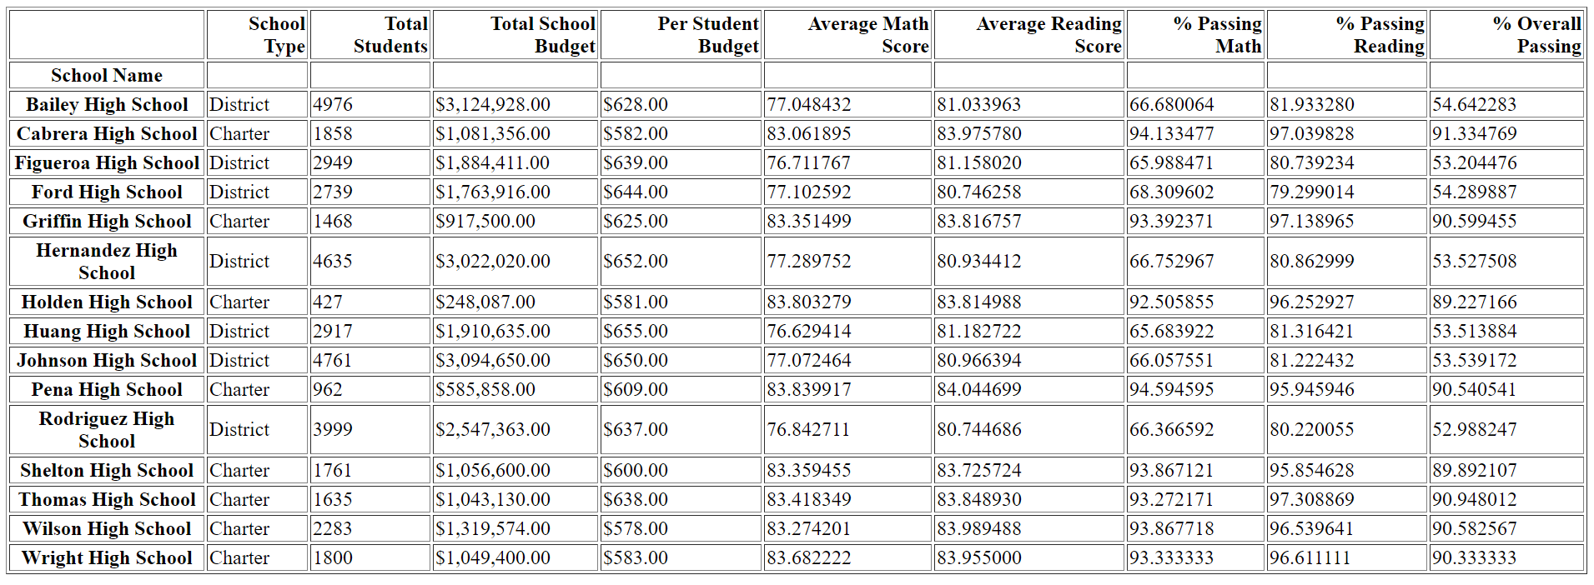

## Top Performing Schools (By % Overall Passing)

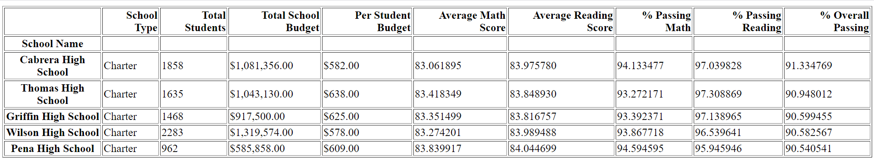

## Bottom Performing Schools (By % Overall Passing)

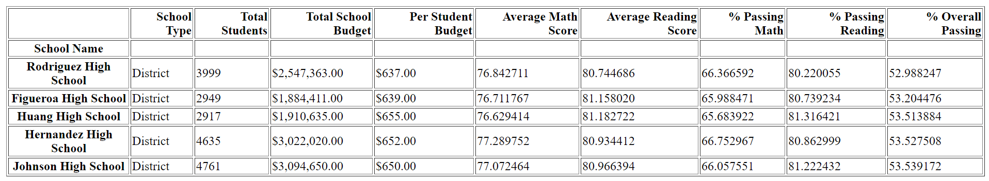

## Math Scores by Grade

|  | **9th** | **10th** | **11th** | **12th** |
| --- | --- | --- | --- | --- |
|  |  |  |  |  |
| **Bailey High School** | 77.083676 | 76.996772 | 77.515588 | 76.492218 |
| **Cabrera High School** | 83.094697 | 83.154506 | 82.765560 | 83.277487 |
| **Figueroa High School** | 76.403037 | 76.539974 | 76.884344 | 77.151369 |
| **Ford High School** | 77.361345 | 77.672316 | 76.918058 | 76.179963 |
| **Griffin High School** | 82.044010 | 84.229064 | 83.842105 | 83.356164 |
| **Hernandez High School** | 77.438495 | 77.337408 | 77.136029 | 77.186567 |
| **Holden High School** | 83.787402 | 83.429825 | 85.000000 | 82.855422 |
| **Huang High School** | 77.027251 | 75.908735 | 76.446602 | 77.225641 |
| **Johnson High School** | 77.187857 | 76.691117 | 77.491653 | 76.863248 |
| **Pena High School** | 83.625455 | 83.372000 | 84.328125 | 84.121547 |
| **Rodriguez High School** | 76.859966 | 76.612500 | 76.395626 | 77.690748 |
| **Shelton High School** | 83.420755 | 82.917411 | 83.383495 | 83.778976 |
| **Thomas High School** | 83.590022 | 83.087886 | 83.498795 | 83.497041 |
| **Wilson High School** | 83.085578 | 83.724422 | 83.195326 | 83.035794 |
| **Wright High School** | 83.264706 | 84.010288 | 83.836782 | 83.644986 |

## Reading Score by Grade

|  | **9th** | **10th** | **11th** | **12th** |
| --- | --- | --- | --- | --- |
|  |  |  |  |  |
| **Bailey High School** | 81.303155 | 80.907183 | 80.945643 | 80.912451 |
| **Cabrera High School** | 83.676136 | 84.253219 | 83.788382 | 84.287958 |
| **Figueroa High School** | 81.198598 | 81.408912 | 80.640339 | 81.384863 |
| **Ford High School** | 80.632653 | 81.262712 | 80.403642 | 80.662338 |
| **Griffin High School** | 83.369193 | 83.706897 | 84.288089 | 84.013699 |
| **Hernandez High School** | 80.866860 | 80.660147 | 81.396140 | 80.857143 |
| **Holden High School** | 83.677165 | 83.324561 | 83.815534 | 84.698795 |
| **Huang High School** | 81.290284 | 81.512386 | 81.417476 | 80.305983 |
| **Johnson High School** | 81.260714 | 80.773431 | 80.616027 | 81.227564 |
| **Pena High School** | 83.807273 | 83.612000 | 84.335938 | 84.591160 |
| **Rodriguez High School** | 80.993127 | 80.629808 | 80.864811 | 80.376426 |
| **Shelton High School** | 84.122642 | 83.441964 | 84.373786 | 82.781671 |
| **Thomas High School** | 83.728850 | 84.254157 | 83.585542 | 83.831361 |
| **Wilson High School** | 83.939778 | 84.021452 | 83.764608 | 84.317673 |
| **Wright High School** | 83.833333 | 83.812757 | 84.156322 | 84.073171 |

## Scores by School Spending

|  | **Average Math Score** | **Average Reading Score** | **% Passing Math** | **% Passing Reading** | **% Overall Passing** |
| --- | --- | --- | --- | --- | --- |
| **Spending Ranges (Per Student)** |  |  |  |  |  |
| **<$584** | 83.46 | 83.93 | 93.46 | 96.61 | 90.37 |
| **$585-629** | 81.90 | 83.16 | 87.13 | 92.72 | 81.42 |
| **$630-644** | 78.52 | 81.62 | 73.48 | 84.39 | 62.86 |
| **$645-675** | 77.00 | 81.03 | 66.16 | 81.13 | 53.53 |

## Scores by School Size

|  | **Average Math Score** | **Average Reading Score** | **% Passing Math** | **% Passing Reading** | **% Overall Passing** |
| --- | --- | --- | --- | --- | --- |
| **School Size** |  |  |  |  |  |
| **Small (<1000)** | 83.821598 | 83.929843 | 93.550225 | 96.099437 | 89.883853 |
| **Medium (1000-2000)** | 83.374684 | 83.864438 | 93.599695 | 96.790680 | 90.621535 |
| **Large (2000-5000)** | 77.746417 | 81.344493 | 69.963361 | 82.766634 | 58.286003 |

## Scores by School Type

|  | **Average Math Score** | **Average Reading Score** | **% Passing Math** | **% Passing Reading** | **% Overall Passing** |
| --- | --- | --- | --- | --- | --- |
| **School Type** |  |  |  |  |  |
| **Charter** | 83.473852 | 83.896421 | 93.620830 | 96.586489 | 90.432244 |
| **District** | 76.956733 | 80.966636 | 66.548453 | 80.799062 | 53.672208 |